 

**Exploratory Data Analysis**









**Dynamic Price Problems**

**Kaggle Airfare Dataset**

**INPUT**

**Feature Engineering**

**Detect Outliers**

**Detect Missing Values**

**Distinguish Attribute**

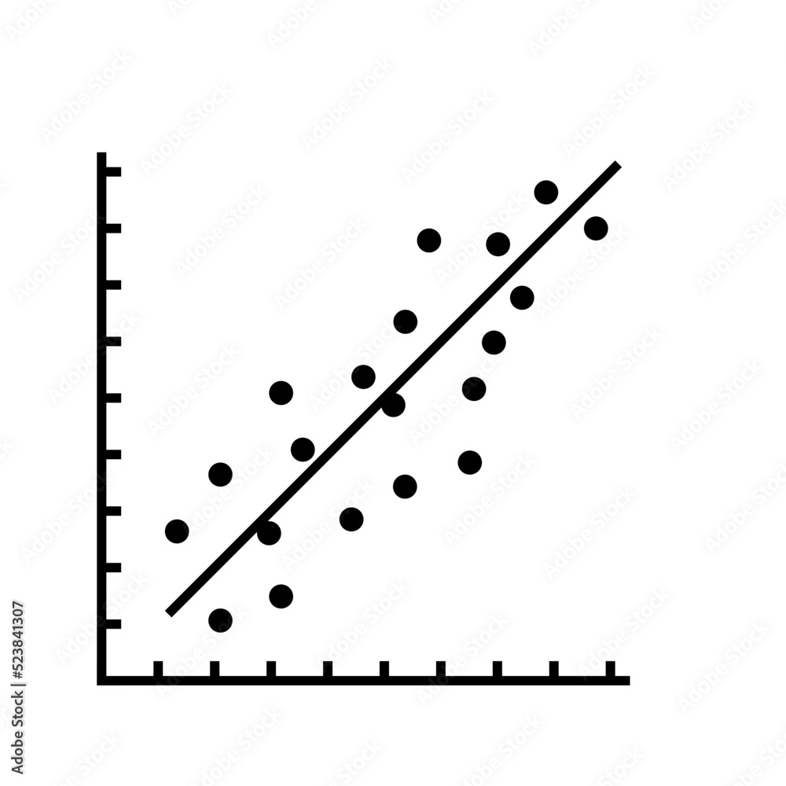





**Regression Models**

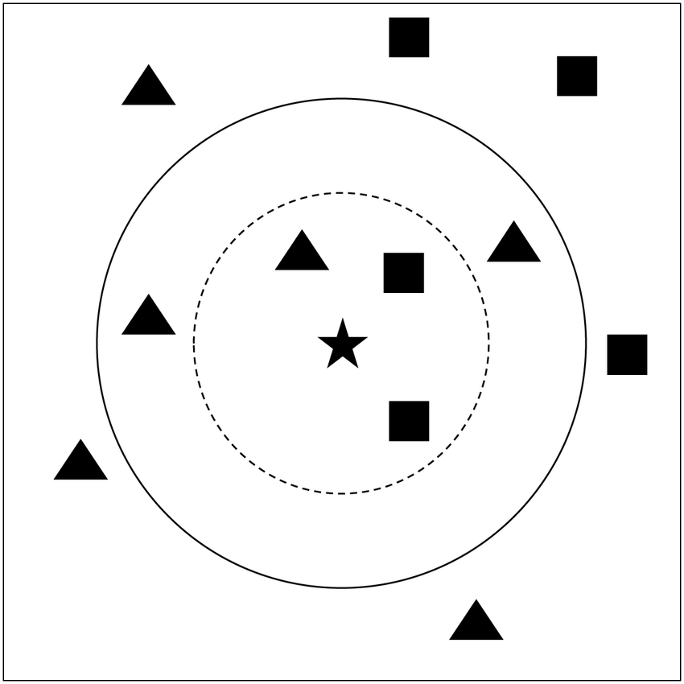

**Clean Dataset**

**Data Pre-processing**





**K Nearest Neighbor**

**Price Prediction**

**Optimal Technique (Random Forest)**

**Random Forest**



**ML Techniques**



 

**Unemployment Problem**

**Covid Dataset**

**Delhi Dataset**

**National Dataset**

**Dataset Types**

**Collected Dataset**







**Unemployment Prediction**



**Combined Result**



**ML Techniques**



**Clean Dataset**



**Exploratory Data Analysis**

**Detect Outliers**

**Feature Engineering**

**Detect Missing Values**

**Distinguish Attribute**









**Data Pre-processing**





**Feature Engineering**

**Detect Outliers**

**Detect Missing Values**

**Distinguish Attribute**







**Regression Models**



**Clean Dataset**

**Data Pre-processing**





**K Nearest Neighbor**

**Price Prediction**

**Optimal Technique (Random Forest)**

**Random Forest**



**ML Techniques**

